PRESS RELEASE

**2025 release: Flexible solutions for the shopfloor**

**TDM Systems presents software updates and TDM Machine Web Client**

* Shopfloor solution available on all common browsers
* Customer feedback as a key driver of development
* Improved displays for TDM Global Line and TDM ClassiX

**Tübingen, 16 January 2025.** **With updates to the TDM Global Line and TDM ClassiX software solutions and the new TDM Machine Web Client, TDM Systems offers powerful and user-friendly solutions that make tool management and supervision on the shopfloor more efficient and easier. The software solutions have additional functions and an improved display in the current version.**

The work of machine operators is demanding and takes place under harsh conditions. Inspired by these challenges and feedback from existing users, TDM Systems is now taking a new approach: With the TDM Machine Web Client, customers can now use a browser-based solution that is available with maximum flexibility on any end device.

**Extensive functions can be used flexibly**

The TDM Machine Web Client is a completely browser-based application that enables machine operators to monitor the tool flow through the shopfloor independently of TDM desktop applications. The system communicates with the TDM application server and is compatible with all TDM desktop applications – whether TDM Global Line or TDM ClassiX. It displays production orders, both from the TDM presetting area and from the shopfloor applications TDMshopcontrol and TDM Shopfloor Manager. In addition, the TDM Machine Web Client shows the magazine contents and a tabular tool overview at a glance, and offers the option to call up detailed tool information. Users can perform various actions for tools, and view job and picklist details.

**Responding to customer wishes**

"With the TDM Machine Web Client, we are responding to a suggestion from our customers and offering machine operators a lean solution that supports them in their daily work," explains Matthias Gröger, Head of Product TDM at TDM Systems, adding: "We take the wishes of our users very seriously, which is why this web client is just the first in a whole series of browser-based solutions that will come in the future."

**Improved software solutions**

The TDM software solutions TDM Global Line and TDM ClassiX, which are both compatible with the TDM Machine Web Client, have also been revised and come with new functions. The TDM Shopfloor Manager from TDM Global Line now also supports additional items, fixtures, and gauge and calibration equipment and has, among other things, an improved display of the stock location status in all relevant tables and widgets. In addition to other functions, TDM ClassiX now also offers an overview of the stock location during storage and retrieval in TDMstoreasy and also takes into account remaining life of a tool and quantities when balancing in TDMshopcontrol, and also displays these.

You can find printable images here: [Pictures](https://drive.google.com/drive/folders/1EndCeg5_rjc3r_dPqPNFwZF9fNnKd25F)

Image 1:

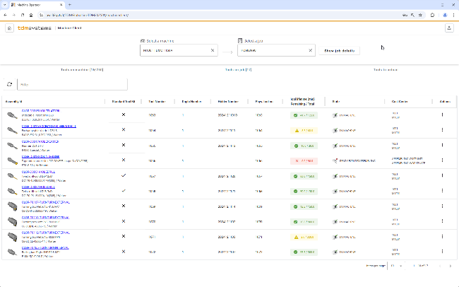

**Caption:** View tools of a selected picklist with tool life information and preparation state.

**Image source:** TDM Systems

Image 2:

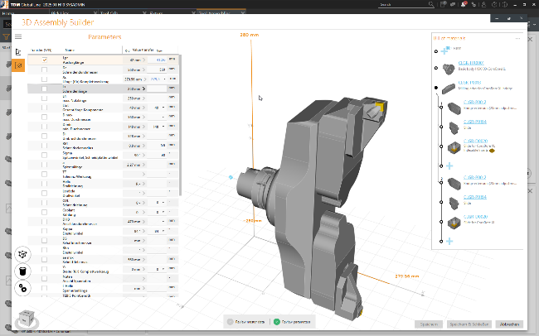

**Caption:** The parameters for data transfer are updated during 3D assembly.

**Image source:** TDM Systems

Image 3:

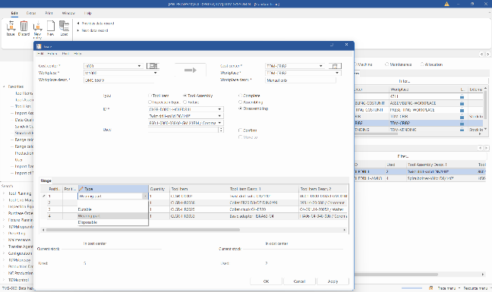

**Caption:** There is a new system parameter in the TDM tool crib module that can be used to change the usage type during disassembly.  
**Image source:** TDM Systems

Image 4:

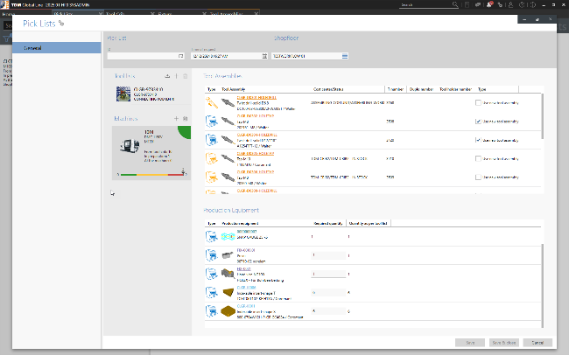

**Caption:** When calculating requirements, production aids such as devices, gauge/calibration equipment and items are taken into account.

**Image source:** TDM Systems

**About TDM Systems**

For over 35 years, TDM Systems GmbH has been the leading provider of tool management solutions in the area of machining. The Tübingen-based company focuses on process optimization through digital tool planning and provision. The core competencies of TDM Systems are the generation of tool data and graphics, integration into CAM planning and tool organization at shopfloor level. TDM Cloud Essentials enables small companies to get started with cloud-based tool management. With the TDM iCut and TDM appCom solutions, TDM Systems now also offers digital assistants for optimizing machine runtimes. TDM Systems is part of the Sandvik Group.

**Company contact:**

TDM Systems GmbH

Christian Kübel

Head of Sales EMEA, APAC & Channel Management

Telephone +49 (0) 7071 9492 1169

christian.kuebel@tdmsystems.com