
News

FOR IMMEDIATE RELEASE

TDM Systems For further editorial information contact:
1901 N. Roselle Suite 800 Ed Szykula, KST Advertising & Public Relations
Schaumburg, IL 60195 szykula@ksthip.com
847. 605.1269 www.tdmsystems.com

TDM Systems to feature Tool Data Management of the future at WESTEC 2017.

Schaumburg, IL—TDM Systems, a leading provider of tool data management in the machining industry will present its new generation of software for Tool Lifecycle Management at WESTEC 2017, Booth No. 2446, September 12-14, 2017, Los Angeles.
TDM Systems will feature its newest software, "TDM next generation" which offers new introductory options as well as highly integrated global system integration. TDM next generation is a state-of-the-art, highly evolved platform that can be used to operate all existing TDM modules and TDM Global Line modules simultaneously. It features enhanced performance, worldwide networking and easy scalability, helping users implement Industry 4.0.
TDM next generation has responded to the ever-increasing digitalization of production and enabling its customers to completely renew and modernize their TDM solutions – without complex system change. The conversion from the previous 2-tier architecture, the new modern 3-tier architecture increases both performance and process reliability while simultaneously reducing installation and service effort. Additional advantages include simplified interface handling, easy use of on-demand and
-more-
TDM Systems to feature...2/ with photo and caption
Embedded photo is for reference only. Hi-res photo is attached as separate file.

browser-based solutions and the combined use of standard and engineering solutions. Our customers will find a solution tailored to their individual needs. TDM Systems will exhibit together with their partner OmegaTMM.
For more than 25 years, TDM Systems has been the leading provider of tool data management in the machining industry. With the Tool Lifecycle Management strategy, TDM Systems is focusing on process optimization through optimal tool planning and provisioning. Creating and editing tool data and graphics, integrating tool know-how and 3D graphics into the CAM planning and organizing the complete tool cycle on the shop floor level are the three core competencies of TDM Systems. As a competence center within the Sandvik Group, TDM Systems draws on the expertise of various tool manufacturers in developing its software products. www.tdmsystems.com

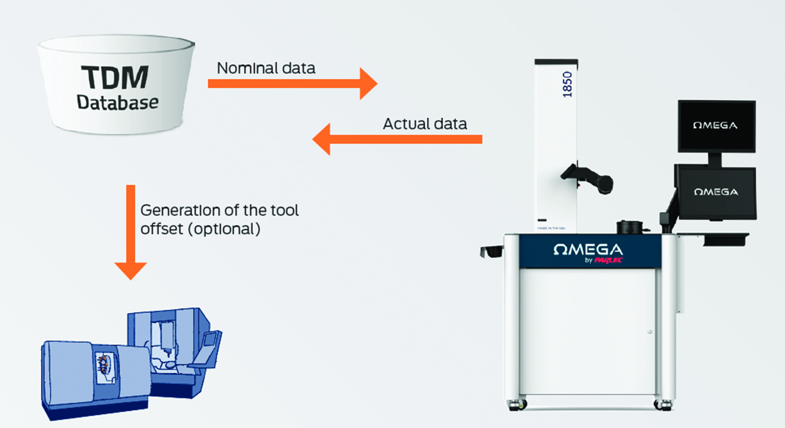

TDM-131 Caption: Thanks to the interface between the Omega system and TDM, proper preparation and exact measurement can be assured - within the requested tolerances.

